**Project Design Phase-II**

**Technology Stack (Architecture & Stack)**

|  |  |
| --- | --- |
| Date | 5 March 2025 |
| Team ID | PNT2025TMID02901 |
| Project Name | Power BI Inflation Analysis: Journeying Through Global Economic Terrain |
| Maximum Marks | 4 Marks |

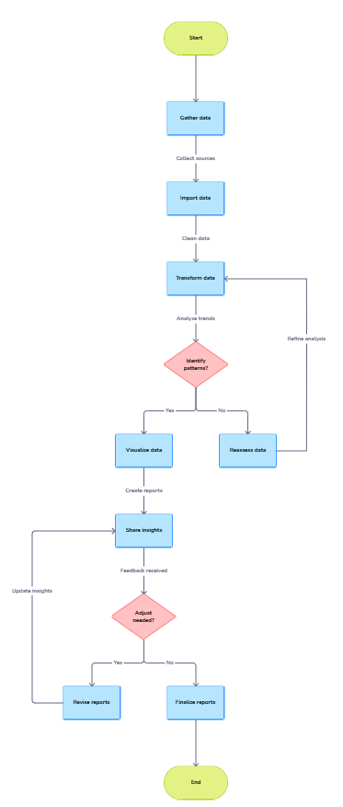

**Technical Architecture:**

The Deliverable shall include the architectural diagram as below and the information as per the table1 & table 2

**Example: Order processing during pandemics for offline mode**

**Table-1 : Components & Technologies:**

Guidelines:

Include all the processes (As an application logic / Technology Block)

Provide infrastructural demarcation (Local / Cloud)

Indicate external interfaces (third party API’s etc.)

Indicate Data Storage components / services

Indicate interface to machine learning models (if applicable)

|  |  |  |  |
| --- | --- | --- | --- |
| **S.No** | **Component** | **Description** | **Technology** |
|  | User Interface | Web-based or desktop Power BI dashboards for visualization | Power BI Service, Power BI Desktop, HTML, CSS, JavaScript (for embedded reports) |
|  | Application Logic-1 | Data extraction and preprocessing logic | Python (Pandas, NumPy), SQL, Power Query |
|  | Application Logic-2 | Data modelling and analysis using DAX | Power BI DAX, R |
|  | Database | Stores processed and raw data | MySQL, PostgreSQL, Azure SQL Database |
|  | Cloud Database | Cloud-based storage and access | Microsoft Azure, AWS RDS, Google Big Query |
|  | File Storage | Storing CSVs, JSON, and historical data | Azure Blob Storage, AWS S3 |
|  | External API-1 | Economic and inflation data sources | IMF API, World Bank API, Federal Reserve API, OECD API |
|  | Machine Learning Model | Forecasting future inflation trends | Scikit-Learn, TensorFlow, Power BI AI Insights |
|  | Infrastructure (Server / Cloud) | Deployment on local systems or cloud | Power BI Service (Cloud), Power BI Report Server (Local), Kubernetes for scaling |
|  | User Interface | Web-based or desktop Power BI dashboards for visualization | Power BI Service, Power BI Desktop, HTML, CSS, JavaScript (for embedded reports) |
|  | Application Logic-1 | Data extraction and preprocessing logic | Python (Pandas, NumPy), SQL, Power Query |

**Table-2: Application Characteristics:**

| **S.No** | **Characteristics** | **Description** | **Technology** | |
| --- | --- | --- | --- | --- |
|  | Open-Source Frameworks | Libraries for data processing and visualization | Technology of Opensource framework | |
|  | Security Implementations | Data encryption, access control, and firewall protection | AES-256, SSL/TLS, IAM, RBAC, OWASP Standards | |
|  | Scalable Architecture | Ensuring scalability for large datasets | Cloud-based deployment, microservices | |
|  | Availability | Load balancing and redundancy for high uptime | Azure Load Balancer, AWS Auto Scaling | |
|  | Performance | Optimizing Power BI reports and query execution | | Caching (Redis), CDN, Power BI Direct Query |